**Word Processing**

**Class Five**

**Lab 13**

|  |
| --- |
| Lab Objectives:  * Introduction to MS Word |

# MS Word

## Microsoft Office Word allows you to create and edit personal and business documents, such as letters, reports, invoices, emails and books.



## By default, documents saved in Word are saved with the .docx extension. Microsoft Word can be used for the following purposes −

## To create business documents having various graphics including pictures, charts, and diagrams.

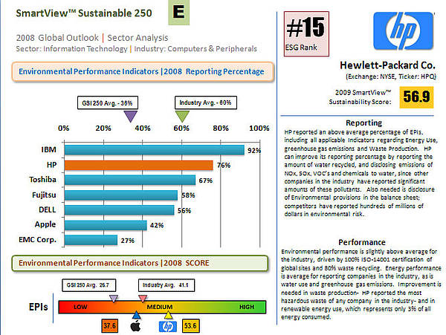

## IMG_256To store and reuse ready made content and formatted elements such as cover pages and sidebars.

## To create letters and letterheads for personal and business purpose.

## To design different documents such as resumes or invitation cards etc.



## This lab has been designed for class five students who are willing to learn Microsoft Word in simple steps and they do not have much knowledge about computer usage and Microsoft applications.

## This lab will give you enough understanding on MS Word from where you can take yourself to higher levels of expertise.

# Getting Started

## There are many versions of MS Office word like word 2007, word 2010, word 2013, word 2016, word 2019 etc. In this lab we will use ms word 2010. You can use any of the version you want

## In this lab, we will discuss how to get started with Word 2010. We will understand how to start a Word 2010 application in simple steps. Assuming you have Microsoft Office 2010 installed in your PC, to start the Word application, follow these steps −

## Step 1 − Click the Start button.

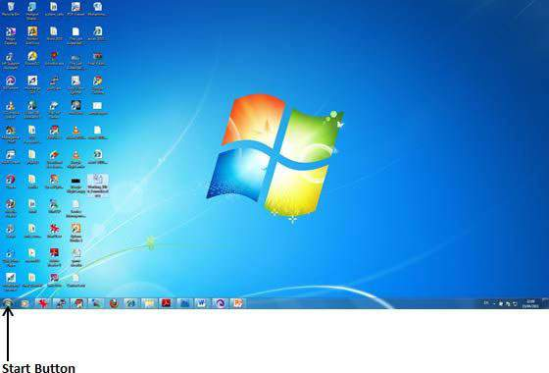

## Step 2 − Click the All Programs option from the menu.

## IMG_257

## Step 3 − Search for Microsoft Office from the submenu and click it.

## IMG_258

## Step 4 − Search for Microsoft Word 2010 from the submenu and click it.

## IMG_259

## This will launch the Microsoft Word 2010 application and you will see the following window.

## IMG_260